|  |
| --- |
| **PROJECT PROPOSAL FORM**  **PROJECT NUMBER : 004**  **PROJECT NAME : Online Gymnastics and Fitness**  **Registration Software** |

A.1. Preliminary Project Information

# A.1.1

|  |  |
| --- | --- |
| **Project No** | 004 |
| **Project Name** | Online Gymnastics and Fitness Registration Software |
| **Start Date** | 03/14/2017 |
| **End Date** | 05/14/2017 |
| **Time** | 61 days |

# A.1.2

|  |  |  |  |  |
| --- | --- | --- | --- | --- |
| **Project Manager** | | | | |
| **Name Surname** | Fatima Habib | **ID No** | | 139250 |
| **Title/Role** | Project manager/ Programmer | | | |
| **Address** | Golin Apartment ,famagusta,TRNC | | | |
| **Phone** | 05338585675 | **Fax** |  | |
| **Email** | Fatemarose1993@gmail.com | | | |

A.2 Company Information

# A.2.1

|  |  |  |  |  |
| --- | --- | --- | --- | --- |
| **Company Owner** | | | | |
| **Name Surname** | Fatima Habib | **ID No** | | 139250 |
| **Title/Role** | Manager | | | |
| **Address** | Golin apartment ,famagusta,TRNC | | | |
| **Phone** | 05338585675 | **Fax** |  | |
| **Email** | Fatemarose1993@gmail.com | | | |

# A.2.2

|  |  |  |  |  |  |  |
| --- | --- | --- | --- | --- | --- | --- |
| **Company Staff Distribution** | | | | | | |
| **Status** | **Phd.** | **Msc.** | **Undergraduate** | **Technic/High School** | **Other** | **Total** |
| **Production** | 1 | 2 | 1 | - | - | 4 |
| **R & D** | 1 | 1 | 1 | - | - | 3 |
| **Other** | - | - | - | - | - | - |

# A.2.3

|  |  |  |
| --- | --- | --- |
| Establishment of the previous year or the last Interim Accounting Period Belongs Financial Information (TL) | Year/Month | 2015/12 |
| Paid-in capital | 30,000 |
| Net Sales Revenue | 60,000 |
| Total Overseas Sales | 10,000 |
| R & D Expenses | 15,000 |
| The Original Product Sales Revenue | 20,000 |
| Current Assets | 90,000 |
| Receivables from Shareholders | 20,000 |
| Common Construction Costs Over Years | 10,000 |
| Short-Term Debt | 10,000 |
| Progress Income | 40,000 |
| Short-Term Bank Debt | 20,000 |
| Equity | 55,000 |
| Establishment of the Last Three Year Average Net Sales | 50,000 | |

# A.2.4

|  |
| --- |
| **List of Completed / Ongoing R & D Projects** |
| 1. Online Students orientation system. 2. Web base online Hospital appointment. 3. Hotel reservatıon system. 4. Online car reservation system. 5. Mobile based hospital appointment reservation system. |

B.1 Introduction to Project

# B.1.1

|  |
| --- |
| **Summary of Project** |
| This project is a gymnastic registration software, that allow users register which include entering users information, record of payment and as well set a start and end date which is the duration of contract. The system will be build in such a way that the administrator (Gym manager) can update each user’s nutritional requirement and important information. |

# B.1.2

|  |
| --- |
| **Key Words** |
| 1. Online Registration 2. Gymnastics and fitness 3. Instructors |

# B.1.3

|  |
| --- |
| **Reason of Starting Project and Aim of Project** |
| Reason for starting this Project was inspired from the need for a more effective registration system to the previous time comsuming manual method still in use by our client. |

# B.1.4

|  |
| --- |
| **Innovative Aspects of Project** |
| * Users instant registration. * Fitness manager can accessible and instant changes to routine. * More users can use the system at a time |

# B.1.5

|  |
| --- |
| **Methods to be Applied** |
| The system is going to be a client/server based system. The method we are going to be applying to achieve this **is** [client-side](https://en.wikipedia.org/wiki/Client-side_scripting)/[server-side](https://en.wikipedia.org/wiki/Server-side_scripting) [scripting](https://en.wikipedia.org/wiki/Computer_programming) , client-side scripts will be embedded with [HTML](https://en.wikipedia.org/wiki/HTML) and CSS , In contrast the [server-side scripts](https://en.wikipedia.org/wiki/Server-side_scripting) is written in the languages [PHP](https://en.wikipedia.org/wiki/PHP), [Java](https://en.wikipedia.org/wiki/Java_(programming_language)), and [server-side JavaScript](https://en.wikipedia.org/wiki/JavaScript#Server-side_JavaScript).   Balancing the execution between client and server scripts is used to minimize the communication load, server load and/or response time. |

# B.1.6

|  |
| --- |
| **Economic and National Outcomes** |
| This project is going to improve the physical and in some cases mental well being of a lot of users, easy Access to online registration means more people signing up even before knowing the location of the establishment . |

B.2 Reason of Starting the Project, Methods and R&D Stages

# B.2.1

|  |
| --- |
| **1- Explain the reason of starting this project. (Max 500 charachter)** |
| Although the primary reason for starting this Project was inspired from the need for a more effective registration system to the previous time comsuming ,manual method still in use by our client, its influence will help users get fast and effective membership to an establishment which importance to society can not be overempashised, home ease registration means more people will be able to register to the gym, which indirectly help cultivate a more fit and health awared society. More over fees will only be accepted on days before or after registration , account information of the established is defined in the system, users will be able to Access, payments are made to the cashier |

|  |
| --- |
| **2- Explain the purpose of this project.** |
| This project is aimed at making the lives of people who will use it easier   1. user will be able to know personal gym start and end dates 2. management can get clients after Office hours 3. management will be able to make schedules for clients more easily. |

|  |
| --- |
| **3- Explain**   * **output of project** * **national / international standards if exist** * **the specific objectives of the project** * **success criterias** |
| **The** **output** of this project is an online Gymnastics and Fitness System.  Since we are developing a web application the standard we are basing the project on is the **World Wide Web Consortium (W3C)** it is **the main international standards** organization for the World Wide Web (abbreviated WWW or W3).  **The specific objective** of this project is to provide an application that enables users to register to the gym online  **Success criterias:**  1. Project is completed on time.  2. Project is completed on budget.  3. Project meets the appropriate quality targets.  4. Project delivered all items within the agreed scope.  5. Project deliverables are fit for purpose.  6. Project meets the commercial objectives for profit, revenue etc.  7. Project meets the functional requirements.  8. Project meets the non-functional requirements e.g. scalability, stability,  availability, performance.  9. Project team satisfaction target is achieved.  10. Project handover to operational team was documented and completed  appropriately.  11. Training was delivered as planned to the appropriate teams.  12. Customer satisfaction target is achieved.  13. Customer/Staff awareness about the project was raised to the  appropriate level.  14. Project uses the approved technology.  15. Project meets all internal appropriate information security policies.  16. Project meets regulatory and compliance targets e.g. health and safety,  legislation.  17. Project meets other targets or benefits identified by the business case |
| **4- Explain**   * **the methods to be applied during R&D activities** * **applications** * **technics and tools to be used** * **standards to be followed under the workflow** |
| **Which SOFTWARE PROCESS MODEL in below will you apply? Why? How? Explain.**  **\* The waterfall model?**  **\*V-model of software process?**  **\*Evolutionary development?**  **\*Component-based software engineering?**  The model we have chosen to use is **component based software engineering**, we decided to do this to reduce software development time, mainenance and production costs, we also decided to do this because of the few personnels involved in the Project and because it’ll increase productivity.  We plan to do this by reusing modules, functions and objects from previous software projects.      **Project Workflow:**   1. **Feasibility and Pre-research:**   A comprehensive feasibility study of social, economical and technical aspects has also been made and implemented as below:-  **Social Feasibility?**   * It has simplified the registration process. * Users can register without even meeting the gym Manager. * It had a good social impact and no objections or problems regarding the project is found   **Economic Feasibility**   * The project is economically Feasible, it was proven to be of ample benefits to the economy of the nation.   **Technical Feasibility**   * Minimum requirement for execution of the project is a php supporting operating system since the connection to the database will be made using php and JavaScript, minimum of 64 MB of RAM, a database software, a server and a web browser with which we were previously equipped with.  1. **System Design:**   According to the system process, the system can be divided into three categories of users: the first users are those who want to register online. The second users are the fitness team. The third is the database administrator  The system will be designed in a way that it has three modules:   1. users module: this will enable users to create an account and also to log in, users will also be able to register,view,edit,cancel ,edit profile. 2. Management module: they will be able to create an account and also to log in 3. Administrator module: The system will also be designed in a way to allow an administrator to monitor all activities add and remove users,view,cancel terminate registration e.t.c.   Users who visit the website can also get information on other features of the system Appropriate permissions are set in the system corresponding to the different user module set.   1. **Software development:**   To develop this system we are going to use a programming languages like:   1. HTML (Hyper Text Mark –up language) for overall structure 2. CSS (Cascade Style Sheet) to give the website a nice appearance 3. JavaScript to implement most of the functions 4. PHP (Hyper Text Preprocessor ) to connect the site to database   We are also going to be using IDE like:   1. Eclipse 2. Aptana Studio   For Database we will be using :   1. MySQL , PhpMyAdmin   And to deploy the website we wıll use the following tools:   1. Amazon Web services 2. FireZilla 3. Name cheap 4. **Prototype implementation and testing work:**   After the proposed system is developed, then the first test that is carried is the **unit test** individual units of [source code](https://en.wikipedia.org/wiki/Source_code" \o "Source code), sets of one or more computer program modules together with associated control data, usage procedures, and operating procedures, are tested to determine whether they are fit for use  After this the entire system is integrated a **integration** **test** is carried out ,individual software modules are combined and tested as a group. if the product passes this test an appropriate technical committee and an appropriate management committee will be chosen for the responsibility for implementation, the product version of system will be delivered to the client, the technical team will assemble and deploy the system as needed and a final test will be carried out by the clients this test is called **acceptance test,** this is a test conducted to determine if the requirements of a [specification](https://en.wikipedia.org/wiki/Specification" \o "Specification) or [contract](https://en.wikipedia.org/wiki/Contract" \o "Contract) are met acceptance testing is also known as user acceptance testing (UAT), end-user testing.   1. **Maintanance:**   In order to maintain this system:   * There will be regular Identifying and repairing 'bugs' or faults in software. * There will be upgrading software as necessary. * Monitoring available system resources, such as disk storage space and system speeds, to ensure that disks do not become over full or that system performance is unacceptable. * Maintaining network servers and responding to problems as they arise. * Managing interfaces with other systems, such as internet, email and intranets. * Providing, monitoring and upgrading security measures such as virus protection, encryption, firewalls and 'hacker' prevention. * Responding to requests for assistance or suggestions from users. |
| **5- Explain**   * **the contribution of national/international technological development if exist** * **starting a new research and development projects within or outside the company** * **launch new applications or research studies in different technology areas**   **With whom we can cooperate?**  **Expectations:**  **Published work:**  **Can your output be an input for other similar national/international projects?** |
| This system is going to contribute to the the national/international development in many ways   * Since this system is going to make use of cloud computing,with cloud computing, companies can reduce the size of their own data centers — or eliminate their data center footprint altogether. The reduction of the numbers of servers, the software cost, and the number of staff can significantly reduce IT costs without impacting an organization’s IT capabilities. * It allows things to be done automatically thereby speeding up technological processes, this is due to the fact that it frees up the staff who would otherwise spend tedious amounts of time checking the availability of these resources manually.   Also this current systems can be used further down the line in other projects, the way the system is being developed most of it’s components can be re-used by other systems, also the project can also be further developed into a mobile application.  **Expectations**  At the end of the the last week we expect to present a system that is working perfectly, users should be able to register and Gym Manager should be able to receive their payment and information. |

B.3 Innovative and Unique Aspects

# B.3.1

|  |
| --- |
| **1- Describe**   * **differences** * **advantages** * **superiority**   **compared to other similar projects.** |
| **DIFFERENCES**  When a user finishes registration he/she is immediately added to the gym database , before payment is even made.    **ADVANTAGES**   1. Saves travel time of users. 2. Registration in the comfort of users’ home. 3. İt is flexible gym management can receives registration at any time of the day   **SUPERIORITY**  The system is reliable,highly adaptable and user-friendly. İt is also easy to understand. Since the system is entirely online, there is no need for complicated installations or updates. The system is incredibly straight forward If there are still any outstanding questions, customers can send their enquiries as a message and the customer care will look into it. |

# B.4.1

|  |
| --- |
| **2- Who can contribute to this project in your company?** |
| 1. Project manager: oversees the project and ensure it is running properly. 2. System analyst: designing and implementing information systems. 3. Database developer/Administrator: Maintains and oversees the database of the system. 4. Programmer : writes software code. 5. User interface designer/ web developer: designs the user interface. 6. Tester : perform various test on system. |

C.1 Gantt Chart and Work Packages

C.1.1 Gantt Chart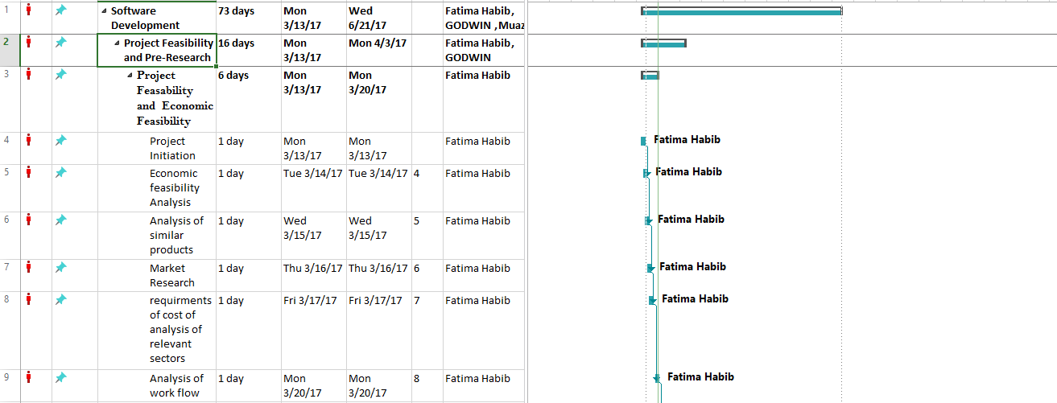

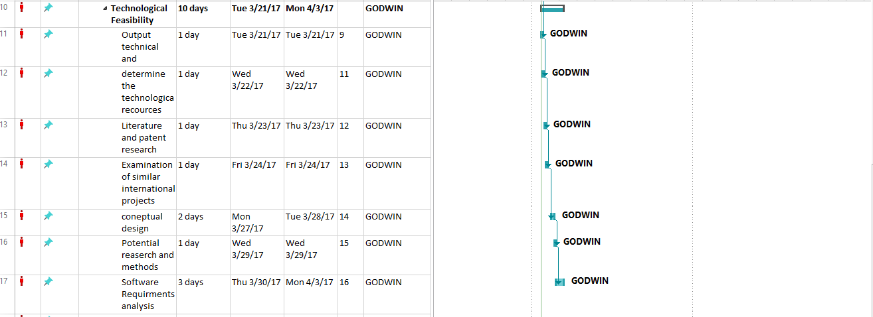

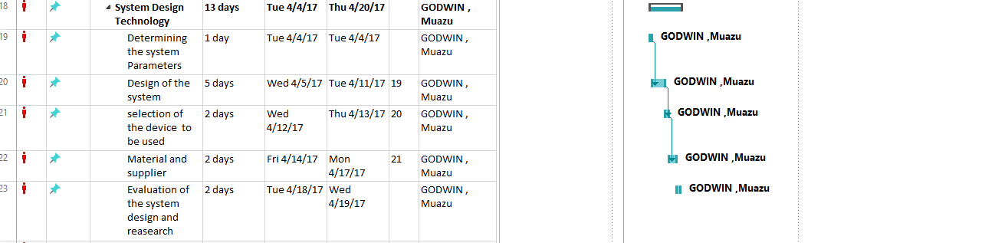

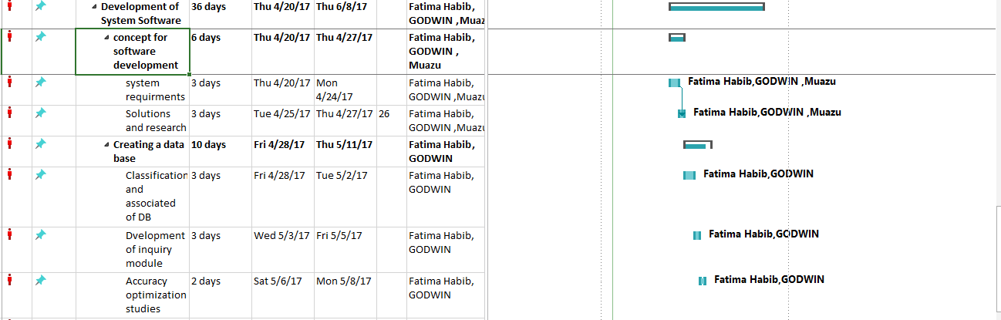

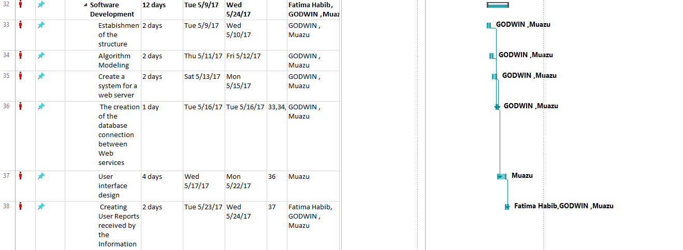

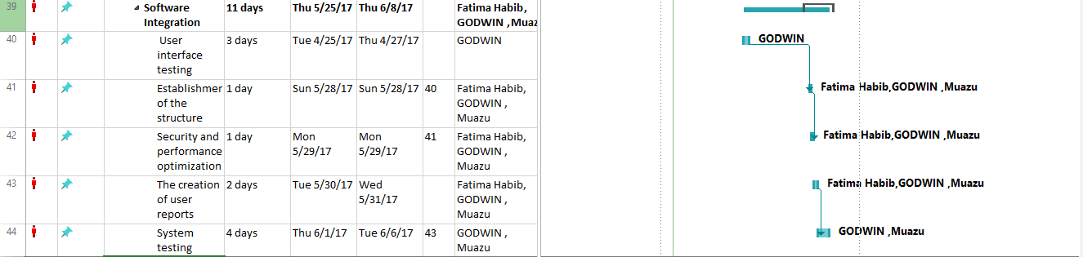

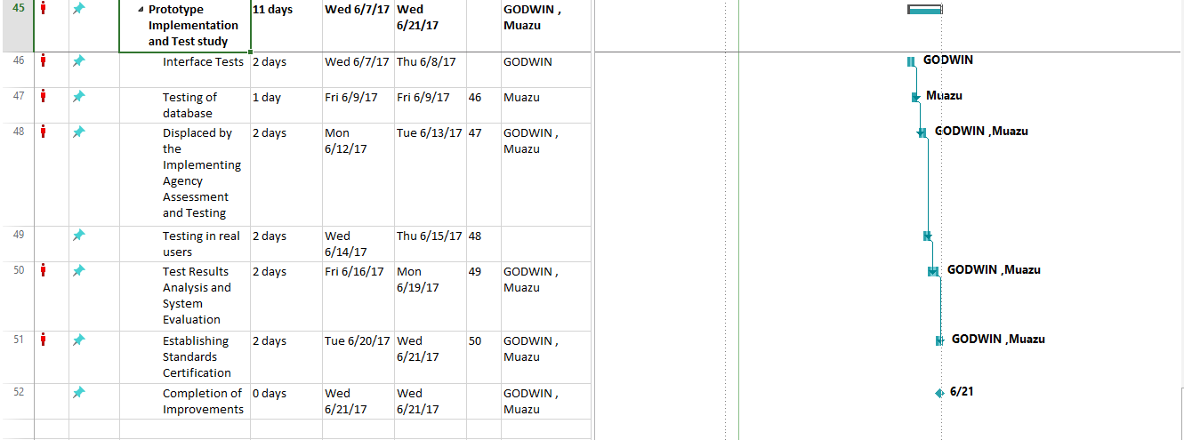

**C.1.2 List of Work Packages**

|  |  |
| --- | --- |
| **Work Package No** | 2 |
| **Work Package Name** | **Project Feasibility and Pre-Research (SRS-Feasibility stage) and Technological Feasibility** |
| **Start-End Date and Time** | 13/3/2017-3/4/2017 |
| **Related Organizations** |  |

|  |
| --- |
| **1- List the activities of work packages.** |
| * 1. **Project Process and Economic Feasibility:** * Determines whether the problems anticipated in user requirements are of high priority. * Determines whether the solution suggested by the software development team is acceptable. * Analyzes whether users will adapt to a new software. * Determines whether the organization is satisfied by the alternative solutions proposed by the software development team. * Cost incurred on software development to produce long-term gains for an organization * Cost required to conduct full software investigation (such as requirements elicitation and requirements analysis). * Cost of hardware, software, development team, and training.   1. **Technological Feasibility:**   2. Analyzes the technical skills and capabilities of the software development team members   3. Determines whether the relevant technology is stable and established   4. Ascertains that the technology chosen for software development has a large number of users so that they can be consulted when problems arise or improvements are required. |
| **2- Describe the methods and parameters that will be used for work package.** |
| In this work package the method is to have meeting with the gym staff try to gather information about trainers and the offered programs, how they make a registration and the time table of the coaches. Estimate the cost of the product and evaluate the possibility of building such software. |
| **3- List the experiments, tests and analysis in the work package.** |
| 1. Requirements elicitation  2. Requirements analysis  3. Use models for software cost estimation, like COCOMO |
| **4- List the output of work package and its success criteria’s.** |
| **Outputs:**  Requirements gathered from the client.  **Success Criteria’s:**   1. Submit the requirements on time. 2. The requirements are agreed with the user expectation. 3. Cost is reasonable**.** |
| **5- Explain the relation of output with other work packages** |
| Good requirements specification allows us to start the design stage without need to go back and change the requirements, and this save time and money. |

|  |  |
| --- | --- |
| **Work Package No** | 2 |
| **Work Package Name** | **Online Gymnastics and Fitness Registration Software (SRS-design stage)** |
| **Start-End Date and Time** | 4/4/2017-20/4/2017 |
| **Related Organizations** |  |

|  |
| --- |
| **1- List the activities of work packages.** |
| 1. Prepare the user requirements document (functional and nonfunctional). 2. Prepare the system requirements document (functional and nonfunctional). 3. Draw the UML diagrams such as Use Cases diagram, sequence diagram, Class diagram, E-R diagram, Data Flow diagram and State chart diagram and etc. 4. Assign the resources to the project levels, distribute the task and determine the schedule. 5. Determine the possible risks. |
| **2- Describe the methods and parameters that will be used for work package.** |
| 1. Use Ms project for assigning the resources and task distribution 2. Use IBM Rational for drawing UML diagrams |
| **3- List the experiments, tests and analysis in the work package.** |
| 1. Analyze user requirements 2. Analyze UML diagrams 3. Carry out acceptance test |
| **4- List the output of work package and its success criteria.** |
| **Outputs:**   1. Work plan. 2. Requirements. 3. Uml diagrams. 4. Assigned resources to each stage of the project.   **Success Criteria:**   1. A good organized plan. 2. Following the working plan. |
| **5- Explain the relation of output with other work packages** |
| Having a documented requirement, design procedure will save the time and money and decrease the possibility of having errors in the next stages. |

|  |  |
| --- | --- |
| **Work Package No** | 3 |
| **Work Package Name** | **X Online Gymnastics and Fitness Registration Software, Creating Database and Software Integration (SRS-Development Stage)** |
| **Start-End Date and Time** | 20/4/2017-8/6/2017 |
| **Related Organizations** |  |

|  |
| --- |
| **1- List the activities of work packages.** |
| 1. Design User interface 2. Design the database 3. Implement functionalities of the website. Such as, login, logout, register and etc. |
| **2- Describe the methods and parameters that will be used for work package.** |
| To develop this system we are going to use programming languages like:   1. HTML (Hyper Text Mark –up language ) for overall structure. 2. CSS (Cascade Style Sheet) to give the website a nice appearance. 3. JavaScript, Ajax to implement most of the functions. 4. PHP (Hyper Text Preprocessor ) to connect the site to database |
| **3- List the experiments, tests and analysis in the work package.** |
| Smoke test to check the critical functionalities. |
| **4- List the output of work package and its success criteria.** |
| **Outputs:**   1. User Interface Design is completed 2. Database is completed 3. Main functions of website is working, which is registration function, user can sign up and log in and check there progress, registration information like start and end time etc.. 4. Different parts of the software working together correctly   **Success Criteria:**  Implementation of the UI, database, website functions will be finished on time according to the work plan. |
| **5- Explain the relation of output with other work packages** |
| Accurate implementation will be useful in testing phase. As much as we the implementation is more accurate and correct the probibility of failure in our website will be reduced and the time and cost for maintenance of the website will be much lower. |

|  |  |
| --- | --- |
| **Work Package No** | 4 |
| **Work Package Name** | **Prototype Implementation and Test Study and Maintenance (SRS-Test & Maintenance stage)** |
| **Start-End Date and Time** | 9/6/2017-21/6/2017 |
| **Related Organizations** |  |

|  |
| --- |
| **1- List the activities of work packages.** |
| 1. Integration test  2. System testing : Non-functional requirements   * 1. Performance Testing   2. Security Testing   3. Usability Testing   4. Reliability and Dependability Testing   5. Endurance testing   6. Load testing   7. Localization testing and Internationalization testing   8. Ergonomics Testing   9. Operational Readiness Testing   10. Installation Testing   11. Configuration Testing   12. Compatibility Testing   13. Interoperability Testing   14. Maintainability Testing   15. Availability Testing   16. Recoverability Testing   17. Miscellaneous Testing   3. Acceptance test  4. Maintenance test  5. Deploy the website |
| **2- Describe the methods and parameters that will be used for work package.** |
| 1. Acceptance test = carry out by user  2. System testing = carry out by tester  3. Maintenance test = carry out by tester  4. Deploy the website:   * 1. Amazon webservice   2. FireZilla   3. Name cheap |
| **3- List the experiments, tests and analysis in the work package.** |
| 1. Integration test.  2. System testing.  3. Acceptance test.  4. Maintenance test. |
| **4- List the output of work package and its success criteria.** |
| **Outputs:**  The website is ready to use and it is available on the web server.  **Success Criteria:**  1. The website reflects the user requirements.  2. All functions of the website are working perfectly. |
| **5- Explain the relation of output with other work packages** |
| There will be no work package left after this work package is done. |

# C.1.3 List of Milestones (should be matched in the gantt chart)

|  |  |  |
| --- | --- | --- |
|  | **Description of Output** | **Expected Time Interval** |
| 1 | Project Process and Economic Feasibility | 10/17/2016 – 10/24/2016 |
| 2 | Technological Feasibility | 10/25/2016 – 11/07/2016 |
| 3 | Design | 11/07/2016 – 11/23/2016 |
| 4 | concept for software development | 11/23/2016 – 11/30/2016 |
| 5 | Creating a Database | 12/01/2016 – 12/14/2016 |
| 6 | Software development | 12/01/2016 – 12/15/2016 |
| 7 | Software Integration | 12/16/2016 – 01/02/2017 |
| 8 | Prototype Implementation and Test Study | 01/03/2017 – 01/20/2017 |

# C.1.4 List of Risks (see below example, search other risks.)

|  |  |  |  |
| --- | --- | --- | --- |
| Risk | Probability | Effects | Your Strategy |
| The time required to develop the software is underestimated. | High | Serious | Implement the most important requirements and ask for extra time to complete the software completely;  Increase the number of staff working on the project to finish the project at the estimated time. |
| Software tools cannot work together in an integrated way. | High | Tolerable | Change the software tools and buy the ones that are compatible with each other. |
| Customers fail to understand the impact of requirements changes. | Moderate | Tolerable | Manager should keep in touch with the customer constantly while preparing the requirements specification document to ensure that all necessary requirements will recognize correctly |
| The rate of defect repair is underestimated. | Moderate | Tolerable | Replace potentially defective components with more reliable bought-in components. |
| The size of the software is underestimated. | High | Serious | Investigate buying sw components;  Investigate use of a program generator. |
| Code generated by code generation tools is inefficient. | Moderate | Insignificant | Change the code generator tools and buy a more reliable one. |
| Key staff are ill at critical times in the project. | Moderate | Serious | Reorganize team so that there is more overlap of work and people therefore understand each other’s jobs. |
| The database used in the system cannot process as many transactions per second as expected. | Moderate | Serious | Investigate the possibility of buying a higher-performance database. |
| Reusable software components contain defects that mean they cannot be reused as planned | Moderate | Serious | Reusable software components have to be repaired before these components are reused; Use the parts that work correctly and change the parts that contain defects. |
| Required training for staff is not available. | Moderate | Tolerable | Manager prepare learning resources for the staff to start learning by themselves and ask their questions from experienced staff; manager itself has control over the learning process |
| Organizational financial problems force reductions in the project budget. | Low | Catastrophic | Remove unnecessary parts from the project;  Reduce number of staff working on project. |
| Changes to requirements that require major design rework are proposed | Moderate | Serious | Change current requirements in a way that we can support new requirements which leads to a minor design change;  Instead of changing current requirements add new requirements to the current requirements. |

C.2 Project Management and Organization

# C.2.1 Project Team

|  |  |  |  |  |  |  |
| --- | --- | --- | --- | --- | --- | --- |
| **Personnel Name** | **Title** | **ID/Passport No** | **Education Status** | **Graduation Date** | **Date of Starting Work** | **Idea Owner** |
| Fatima Habib | Manager/  Programmer | 139250 | Phd. | 2012 | 10/17/16 | yes |
| Lawal Muazu | Tester | 147971 | Phd. | 2011 | 10/17/16 | --- |
| Godwin Jethro | DataBase Developer | 147595 | Bsc. | 2011 | 10/17/16 | --- |
| Fatima Habib | DataBase Developer | 139250 | Msc. | 2013 | 10/17/16 | --- |
| Fatima Habib | programmer | 139250 | Bsc. | 2013 | 10/17/16 | --- |
| Lawal Muazu | User Interface Designer | 147971 | Msc. | 2014 | 10/17/16 | --- |
| Godwin Jethro | Analyst | 147595 | Msc. | 2015 | 10/17/16 | --- |

# C.2.2 Organization Scheme

Res.Asst.Begum Koru

Customer

Asst.Dr.Duygu Celik

Academic Advisor

Fatima Habib

Project Manager

Software Team

GODWIN JETHRO

Data Base Team Leader

Analysis and Testing Team

GODWIN JETHRO

DB Developer

Fatima Habib

DB Developer

LAWAL MUAZU

User interface Designer

GODWIN JETHRO

Analyst

LAWAL MUAZU

Tester

Fatima Habib

Programmer

D.1 Economic Forecasts

|  |
| --- |
| **1- Evaluate the commercialization potential of project outcomes. List possible risks here?** |
| The process of commercialization is broken into phases. The initial phase is introduction of the product into the market. Since our product has a level of public value that results in overall profitability we can pass this phase successfully. Then we need to bring the product into the market and we need advertising efforts to bring awareness of the product to consumers in the target market and because we are working for a Gym and Fitness Center that has its own members we start using product in Gym and start our advertising to introduce to other Gyms and members as well. At the end, our product is known to all people and Gym and Fitness Centers. |

|  |  |
| --- | --- |
| **2- List your expectations to your company which are come by your project** | |
| Time-to-market (month): | 2 months |
| The expected increase in sales revenue (%): | 40% |
| The expected increase in market share (%): | 70% |
| Time to start to gain: | 4 months after release |

D.2 National Outcomes

|  |
| --- |
| **1- Specify the output that may be subject to patent, utility model and industrial design registration in the project.** |
| Since the output of our product is a minor invention, which means there are such systems all around the world but there is not any in Cyprus, and it has an important role in a local innovation system our project subjects to utility model. |
| **2- Explain the potential of project and its outputs that may have an effect on social life, education, health and etc.** |
| The output of our project has an effect on social life, education as well as on health. It affects social life in a way that it helps the Gym users to easily check their Daily weight and food recommendation, it also allow them to know when their Gym period is ending so users can know exact time of renewing contract, it also contribute in time saving. Also it helps Gym Managers to easily manage their customers and their Daily meal recommendation. So this leads to a better health, fitness and Gym system. |
| **3- Explain the positive and negative effects of project outputs for environment and human being.** |
| **Positive effects:**   1. Save time 2. Help in proper storage of users information 3. Enhance Gymnastic fitness registration system   **Negative effects:**   1. If the system crashes it gets difficult to control the members information 2. System is working with electricity so in the case of power failure new users can not be registered and they can be lost. |

(M013) Instrument / Equipment / Software / RELEASE PURCHASES

|  |  |  |  |  |  |  |  |  |  |  |  |
| --- | --- | --- | --- | --- | --- | --- | --- | --- | --- | --- | --- |
| **Project Name** | | **Online Gymnastic and Fitness Registration System** | | | | | | | | | |
| **Line no** | **Instrument / Equipment / Software / Publication Name** | | **No. of Item** | **Capacity** | **Technical specification** | **Purpose of Project Activities** | **Post-Project Place of Use / Purpose** | | **Unit Price (USD)** | **Unit Price (TL)** | **Total Amount (TL)** |
| **R & D** | **Production** |
| **1** | Xampp Server | | **1** |  | Website based server for testing step by step implementation of codes. | To help run the system on an offline server before hosting |  | ✓ | - | - | - |
| **2** | Notepad++ | | **1** |  | open source development tool for the open web | For building, editing, previewing and debugging HTML, CSS and JavaScript websites |  | ✓ | - | - | - |
| **3** | MySQL, PhpMyAdmin | | **1** |  | open-source relational database management system | To create a database |  | ✓ | 5,000 | 15405.75 | 15405.75 |
| **4** | FireZilla | | **1** |  | cross-platform FTP application | For transferring files over the Internet. |  | ✓ | - | - | - |
| **5** | MS Project | | **1** |  | project management software | To assist in developing plans, assigning resources to tasks, tracking progress, managing budgets and analyzing workloads. |  | ✓ | 589.99 | 1817.85 | 1817.85 |
| **6** | IBM RATIONAL ROSE tool | | **1** | 400 MB | An [object-oriented](http://searchsoa.techtarget.com/definition/object-oriented-programming) Unified Modeling Language | To create the SRS document and UML diagrams for our project |  | ✓ | - | - | - |
| **7** | Name cheap | | **1** |  | Domain Manager | To set up our domain |  | ✓ | 10.29 | 31.71 | 31.71 |
| **8** | Amazon Web services | | **1** |  | cloud computing | The flexibility to launch our application regardless of our use case or industry. |  | ✓ | 603 | 1859.47 | 1859.47 |
|  |  | |  |  |  |  |  |  |  | **TOTAL** | **19,114.78 TL** |

(M030) Quarterly Estimated Cost Form (TL)

|  |  |  |  |  |
| --- | --- | --- | --- | --- |
| **Project Name :** | | | | |
| **Cost Item** | **20..** | | **TOTAL**  **(TL)** | **TOTAL COST RATE OF CONTENTS (%)** |
| **I** | **II** |
| **Personnel** | 44500 TL | 44500 TL | 89000 TL | 36.61 % |
| **Travel** | 3000 TL | 3000 TL | 6000 TL | 2.47 % |
| **Instrument / Equipment / Software / Publications** | 19,114.78 TL |  | 19,114.78 TL | 7.86 % |
| **Domestic Works Made By R & D and Testing Institutions** | 12000 TL | 12000TL | 24000 TL | 9.87 % |
| **International Works Made By R & D and Testing Institutions** | 18000 TL | 18000 TL | 36000 TL | 14.81 % |
| **Domestic Services Procurement** | 15000 TL | 15000 TL | 30000 TL | 12.34 % |
| **Overseas Service Procurement** | 12000 TL | 12000 TL | 24000 TL | 9.87 % |
| **Material** | 10000 TL | 5000 TL | 15000 TL | 6.17 % |
| **TOTAL COST** | 133614.78 TL | 109500 TL | 243114,78 TL | 100 % |
| **CUMULATIVE COST** |  |  |  | 100 |
| **IN THE PROJECT TOTAL MAN-MONTH** | | | 2700 TL | |

APPENDIX